**What is a Minor Injury?**

All patients who attend the Minor Injuries Unit will be assessed by a trained nurse.

If their condition cannot be treated here, they will be referred to the most appropriate service. E.g. A&E, GP or practice nurse.

**Will I see a Doctor?**

**No.  
There are no doctors at the Minor Injuries Unit.**

**The service at the unit is provided by nurses who have extended skills and experience in dealing with accidents and emergencies.**

**If the nurse who assesses you considers that you need to see a doctor, you will be referred to the most appropriate service.**

**Can I get an X-Ray?**

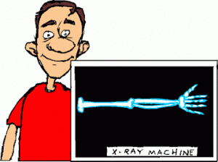

If the nurse suspects that you have broken a bone, she/he can request an x-ray. This will be done at the Herts and Essex hospital



**We CAN treat:**

**Minor cuts and grazes  
Cuts needing stitches  
Bites and stings  
Sprains and strains  
Sports injuries  
Suspected limb fractures requiring X-ray  
Anti-tetanus injections  
Minor abscesses  
Burns/scalds  
Removal of foreign bodies (such as splinters, fish hooks, cotton buds, earring butterflies)  
Minor head injury  
Minor limb injury  
Whiplash (neck/headache following a low speed car accident)**

***We try to assist wherever we can but should you arrive:***

* ***with any conditions NOT listed above***
* ***with a child under 2 years of age***
* ***or after 4.30pm***

***We will redirect you to a more appropriate NHS service****.*

**Video consultations are available.**

**Please call 01279 827450 to book.**



**We DO NOT treat:**

**Children under 2 years old  
Dressing changes  
Removal of stitches  
Chest pain  
Abdominal pain  
Back pain  
Eye problems  
Ear infections  
Dizzy spells  
Sore throat  
Asthma  
Gynaecological complaints  
Mental Health problems  
Intoxicated patients**

**Please note that the Emergency Nurse Practitioners in MIU can NOT authorise X-rays of:   
HEAD  
NECK  
THROAT  
FACE  
CHEST/RIBS  
BACK/SPINE**

**Still unsure?**   
If you are unsure whether we can treat you – just call us

**Minor Injuries Unit  
Herts and Essex Community Hospital  
Cavell Drive, off Haymeads Lane  
Bishop’s Stortford  
CM23 5JH**

**Phone – 01279 827450**  
Website - https://www.hct.nhs.uk

**Opening Times**

**Mon-Fri 9am -4.30pm(last registration)**

**Closed weekends and bank holidays**

**Phone – 01279 827450**

**We are pleased to receive comments/feedback on our service.**

**Contact Patient Advice and Liaison Service**

**Freephone – 0800 0111 6113**

**Email:** [**pals.hchs@nhs.net**](mailto:pals.hchs@nhs.net)

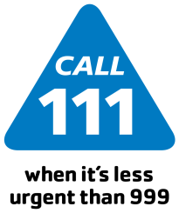

**NHS 111**

Telephone advice service available 24 hours a day

Minor Injuries Unit  
Herts and Essex Community Hospital  
Cavell Drive, off Haymeads Lane  
Bishop’s Stortford  
CM23 5JH

Phone – 01279 827450  
Website - https://www.hct.nhs.uk

**Please call 01279 827450 to**

**book a video consultation.**

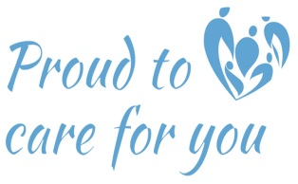





***Minor Injuries Unit***

***Herts and Essex Hospital  
  
01279 827450***

**Opening Times**

**Monday – Friday**

**9am – 4.30pm (Last Registration)**

**Closed weekends and Bank Holidays**  
